Aerionna Stephenson

7 May 2018

PA04

Reflection and Paper

Paper and Reflection

First, I started with the following image where there are two objects that are visible and one that is not. The colors for the specular lights are red and blue while the emissive material is emitting the color red. As soon as I was able to objects to glow red, I began to work on the creative part of the assignment.

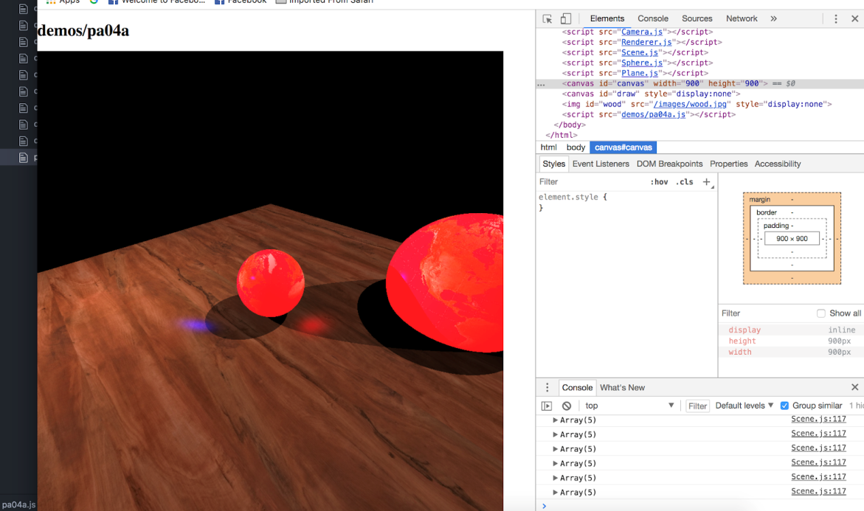

**Image of Scene Before Changes**

I first changed the textures in the scene by adding my own images too my files. I created three new textures for the objects. Then, I had noticed that there were a total of three spheres, but I could only visibly see one on the screen. I had to adjust the position of the third sphere until I could view it in the camera. Then, I decided to add one more object to the scene, another sphere. After looking at my scene, I really did not like the way the camera was above the scene. I wanted it to be at the same level as the objects so that the user could feel like they are actually in the scene, viewing the objects at eye-level. Next, I decided that I did not want all the objects to utilize the emissive light. Therefore, I only chose one sphere to have emissive light material. I made the color a lime green. Afterwards, I started to alter the settings for the two lights in the scene. I changed the location of both lights and their intensities. The first light’s diffuse color was changed to red while the second light’s diffuse color was white. I really liked how in the original scene, there were two specular colors, red and blue. For the purposes of my scene, I thought that they should be purple and light blue. Lastly, there was one thing that I felt was still off about the scene, the location of the objects. I had to translate them to make them closer to the camera so the user can feel like they can touch them. This is how I produced the scene that is shown in the picture below.

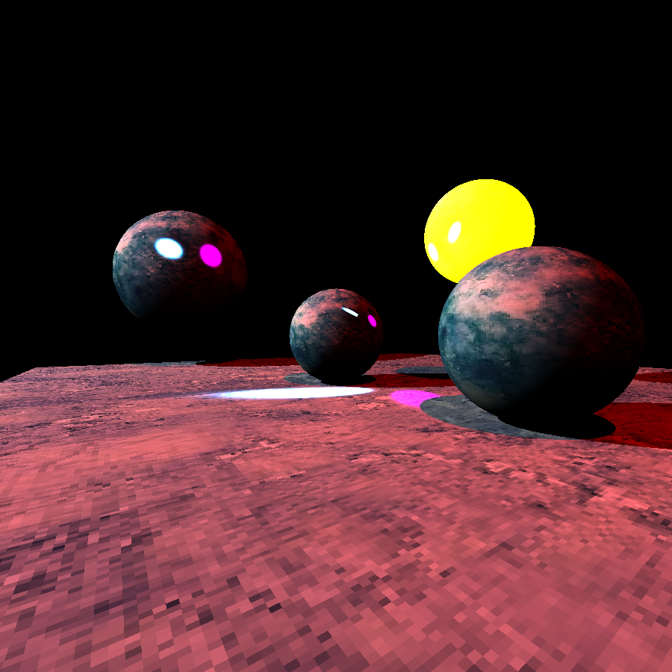

**Image of Scene After Changes**

This project has mainly taught me the difference between emissive, diffuse, and specular light. Emissive light is use to make a material glow or self-illuminating by giving off the illusion that it is emitting light even though it is really not. Diffuse light is the light that is produced while the object is under pure white light. Specular light is the color of the light that is reflected.

Reflection

This Project was extremely difficult for me because I had trouble understanding the lesson on Ray Tracing. Also, I was having trouble coding on my computer because it was running very slow and wouldn’t allow me to see the code in the ray tracer file. I had to use one of my friend’s computer to complete the assignment. I did really well with creating a new scene because I was able to completely change the scene to make it different from the original scene that was given to us. Overall, I am happy with the finished product, but I would try to add more different shapes to the scene besides the sphere and square if I had more time. From completing this project, I was able to develop my creative thing skills and learned about emissive material, diffuse color, and specular color.